Create three VM’s . One Windows 2016 server, other linux, put them in same ASet.

Now check asset. All three servers will be running in three different fd, ud

Steps to create Availibility Set

l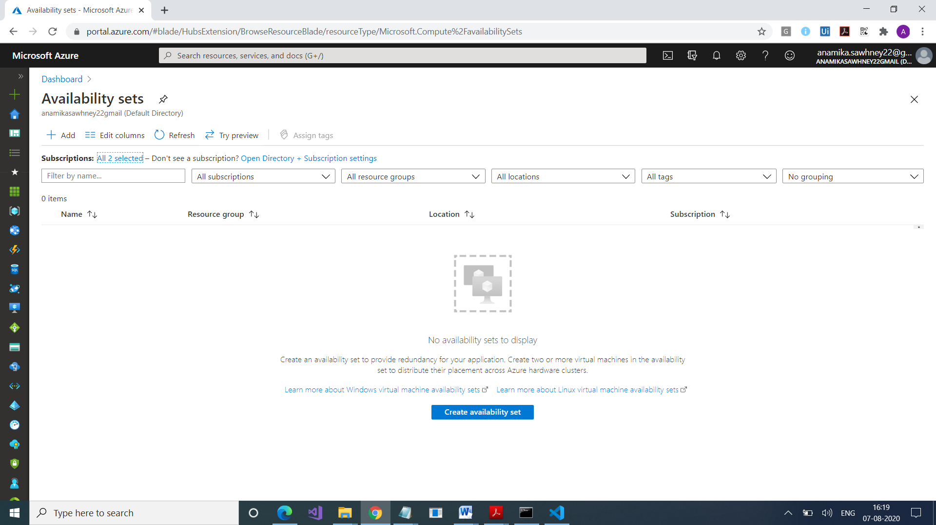

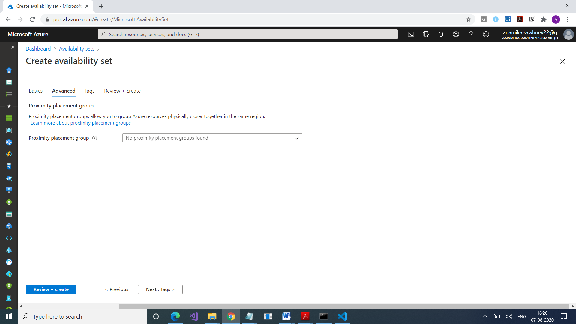

What is Proximity Placement Group : It’s a service which to keep the servers in close proximity ,i.e. close to each other. Purpose is low latency

